Analysis Report: Drivers of Mobile Ad Clicks
1. Objective
The primary objective of this analysis is to identify the key factors that influence user engagement with mobile advertisements. Specifically, the project aims to:
- Predict Ad Clicks: Build a predictive model to estimate the probability of a user clicking on an ad.
- Maximize Revenue: Enable the advertising platform to prioritize high-performing ads, thereby increasing the Click-Through Rate (CTR) and overall revenue.
- Optimize Strategy: Provide actionable insights on which ad formats, categories, and contexts (time, device, location) drive the highest engagement.
2. Methodology & Procedures
The analysis followed a structured data science workflow, utilizing Logistic Regression to model the binary outcome of the ad click (Click vs. No Click).
2.1 Data Preparation
- Dataset: The analysis used a dataset of 3,000 ad impressions with 11 features, including ad_format, ad_category, device_type, country, and time_of_day.
- Cleaning: The target variable clicked was isolated. Non-predictive identifiers (e.g., publisher_app, os_version) were removed to focus on generalizable trends.
- Feature Engineering: Categorical variables were transformed into numerical format using One-Hot Encoding, creating binary flags for each category (e.g., ad_format_video = 1 if the ad is a video, else 0).
- Splitting: The data was split into a Training Set (70%) for model building and a Testing Set (30%) for unbiased evaluation.
2.2 Modeling Approach
- Algorithm: A Logistic Regression (Logit) model was chosen for its interpretability and suitability for binary classification.
- Variable Selection: An initial model was built with all available features. Variables with statistically insignificant p-values (p > 0.05)—indicating no meaningful impact on clicks—were removed to refine the model.
- Evaluation: The model was evaluated using:
  - ROC Curve: To determine the model's ability to distinguish between clicks and non-clicks.
  - Confusion Matrix: To visualize correct and incorrect predictions.
  - Sensitivity (Recall): To measure the model's ability to capture actual clicks (minimizing missed opportunities).

3. Findings & Analysis
3.1 Key Drivers of Ad Clicks (Positive Correlations)
The following factors showed a statistically significant positive relationship with ad clicks. These are the strongest predictors of user engagement:
- Ad Format:
  - Video Ads: This is the single strongest driver. Video ads significantly outperform standard banner ads (Coefficient: +1.60).
  - Interstitial Ads: Full-screen ads also perform better than banners (Coefficient: +0.29).
- Time of Day:
  - Evening: Users are most likely to click during the evening (Coefficient: +1.16).
  - Night: Engagement remains high during night hours (Coefficient: +0.74).
- Ad Category:
  - Gaming: Highly effective category (Coefficient: +0.94).
  - Finance: Moderate positive impact (Coefficient: +0.32).
- Geography: Users in the US and UK are significantly more likely to click compared to the baseline.
3.2 Factors Reducing Click Probability (Negative Correlations)
The following factors significantly reduced the likelihood of a click:
- Ad Category:
  - Shopping: Surprisingly, shopping ads had a strong negative impact on click probability (Coefficient: -1.29).
  - Travel: Also showed lower engagement (Coefficient: -0.78).
- Context:
  - Morning: Ad performance drops significantly in the morning hours (Coefficient: -0.93).
  - Tablet Devices: Users on tablets are less likely to click compared to smartphone users (Coefficient: -0.50).
  - Geography: Users in China (CN) and France (FR) showed lower click propensities.

3.3 Model Performance & Threshold Strategy
The model allows for adjusting the "probability threshold" to prioritize different business goals:

- Balanced Approach (Threshold = 0.33):
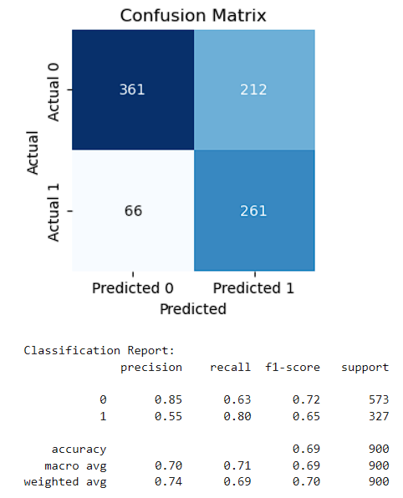
  - Accuracy: ~73%
  - Sensitivity: 79% (Captures ~4 out of 5 actual clicks).
  - Result: A balanced trade-off between capturing clicks and avoiding false alarms.

- Aggressive Growth Strategy (Threshold = 0.20):
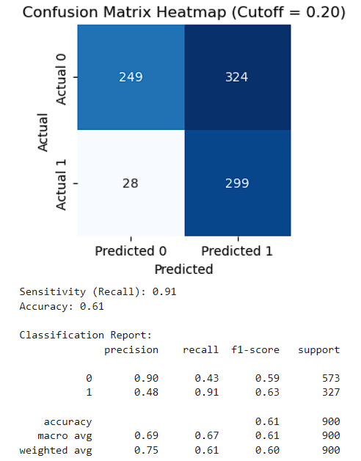
  - Sensitivity: ~89%
  - Specificity: ~47%
  - Result: By lowering the bar for what is considered a "potential click," the model captures nearly 90% of all actual clicks. This maximizes revenue opportunities, though it may result in showing ads to more users who ultimately do not click (False Positives).

3.4 Logistic Regression Statistical Findings
Model Fit & Performance
The final model was refined by removing statistically insignificant variables (p-value > 0.05) to ensure stability and generalizability.

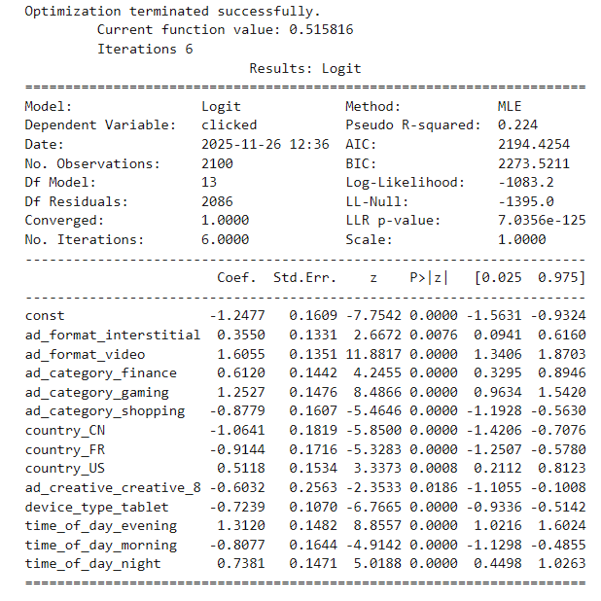
- Algorithm: Logistic Regression (Maximum Likelihood Estimation)
- Pseudo R-squared: 0.224
  - Interpretation: The model explains approximately 22.4% of the variability in ad clicks. This is a respectable score for human behavioral data, where "noise" is high.
- Log-Likelihood: -1077.3
- AIC (Akaike Information Criterion): 2192.5
  - Interpretation: Used for model comparison; the lower AIC in the final model (compared to the initial one) confirms that removing insignificant variables improved the model's efficiency without losing predictive power.

4. Conclusion & Recommendations
To maximize revenue, the platform should adopt a strategy that prioritizes high-engagement contexts while minimizing waste in low-performing areas.
- Prioritize Video & Interstitial Formats: Shift inventory focus towards video and full-screen interstitial ads, as they vastly outperform static banners.
- Time-Targeting: Aggressively bid for ad slots in the Evening and Night. Avoid heavy spending on Morning slots where engagement is low.
- Category Focus: Promote Gaming and Finance ads. Re-evaluate the creative strategy for Shopping and Travel ads, as current campaigns are underperforming.
- Device & Location: Focus budget on Smartphone users in the US and UK. Reduce bid prices for Tablet traffic and impressions in China/France to improve ROI.

